Jira Software Your work vFilters v Dashboards v People v Apps v

Projects / Customer Care Registry / CCR board Reports

# Burndown Chart

CCR sprint 3 Issue Count  How to read this chart

|  |
| --- |
| Q Search |

|  |
| --- |
| Guideline  Remaining Values  Non-Working Days  Show Non-Working Days |
|

 •



Projects

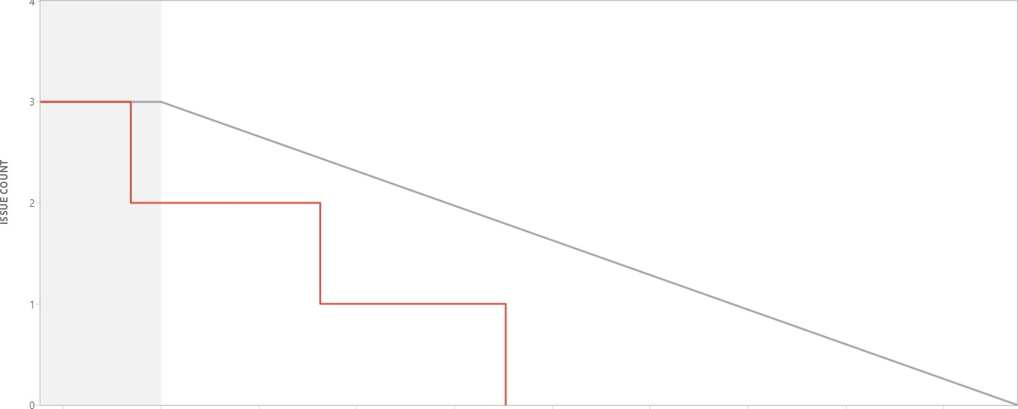

4

Nov 6 12:00 Nov 7 0:00 Nov 7 12:00 Nov 8 0:00 Nov 8 12:00 Nov 9 0:00 Nov 9 12:00 Nov 10 0:00 Nov 10 12:00 Nov 11 0:00

TIME

Issue Count



Date Issue Event Type Event Detailpgc. Remaining

|  |  |  |  |  |
| --- | --- | --- | --- | --- |
| 06/Nov/22 1 AM  06/Nov/22 8:17 PM  07/Nov/22 7:30 PM  08/Nov/22 6:16 PM  08/Nov/22 6:18 PM | CCR 13 CCR-14 CCR-15  CCR-14  CCR-15  CCR-13  CCR-13 CCR-14  CCR-15 | Sprint start  Burndown  Burndown  Burndown  Sprint ended by Bala Abinesh Surya | Issue completed  Issue completed  Issue completed | 3  2 |